MEMORANDUM

DATE: June 08,2015
TO: Yang,He
FORM: Jun,Luo International school
SUBJECT: Process Report Of The Digital Circuit Design
INTRODUCTORY SUMMARY
We did the second circuit experiment with NAND gate, OR gate and AND gate. NAND gate means when it get high input it offer a low output. OR gate means any of two input is high then the output is high. The last AND gate means only two input is high we could get high output.
We plan to use these gate to build an adder circuit.
LAB MATERIALS
NAND gate
OR gate
AND gate
Laboratory power supply
Wire
Bread board
Voltmeter
LAB PROCEDURE
In this experiment, we have to do preparatory work like learning the usage of all things above, and know the principle of the adder circuit.
Step1 Create a half adder
Construct the NAND implementation of the Half Adder which is given as follow. Checking its operation against the truth table ,verify the circuit is functioning correctly as a Half adder.
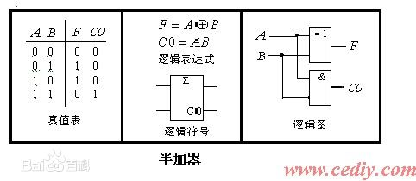
Step2
Put the chips on bread board , make sure the wire is correctly functioning .offer power and check if it work as designed.
Step3 Create Full Adder
Build a Full Adder from two NAND gate Half Adder and check its operation against the Truth Table. Your answer should include a fully labelled circuit diagram.
Put the chips on bread board , make sure the wire is correctly functioning .offer power and check if it work as designed.
CONCLUSION
This experiment taught me the basic method of building Half Adder and Full Adder . We fundamentally knowing how it work and how it is built

